Designing of spine porous bone replacements by
Ti based amorphous metallic glassy gradient porous foams
fabricated by 3D printing selective laser melting

1 研製成功3D列印專用之多元鈦基非晶金屬玻璃粉體材料
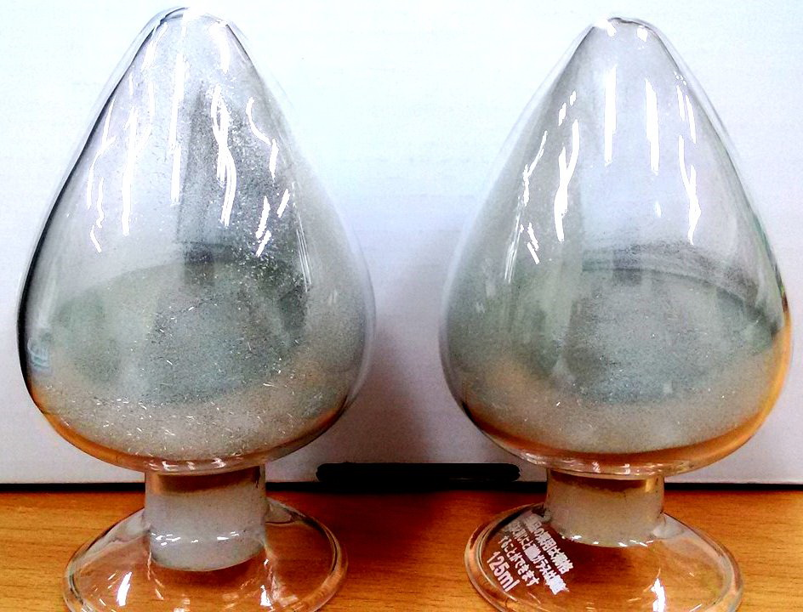

2. 自行設計骨支架數位軟體模型參數及3D列印成品
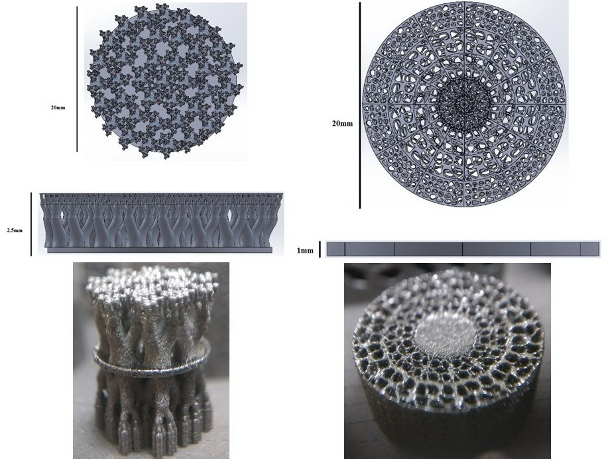
3. 雷射3D列印之多元合骨支架成品樣本
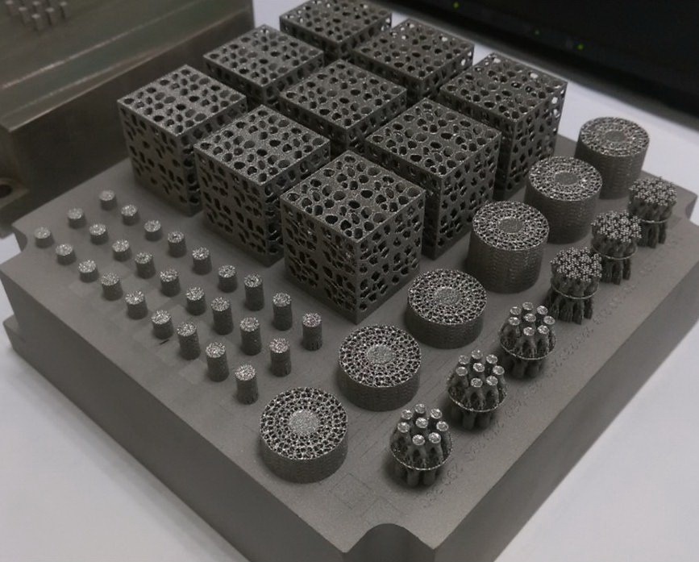

4. 3D列印多元漸進多孔成品植入豬隻脊椎成功
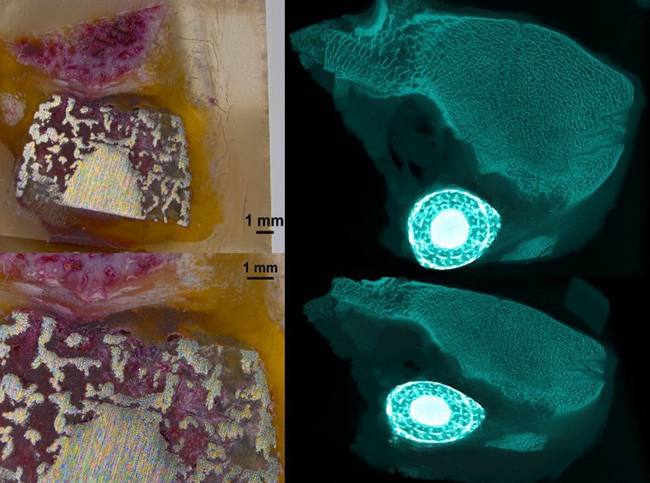
5. 漸層多孔多元鈦基金屬玻璃椎體骨支架設計植入流程及相關比賽成果

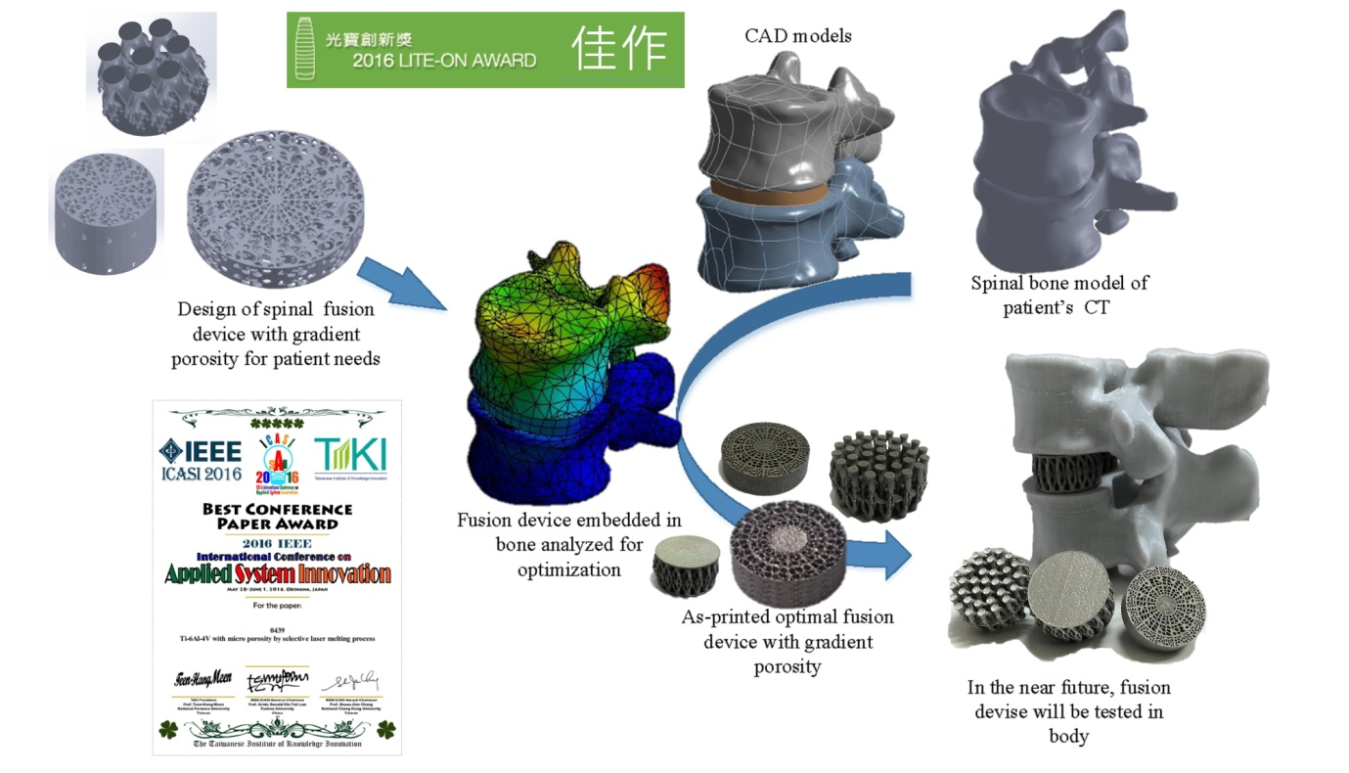

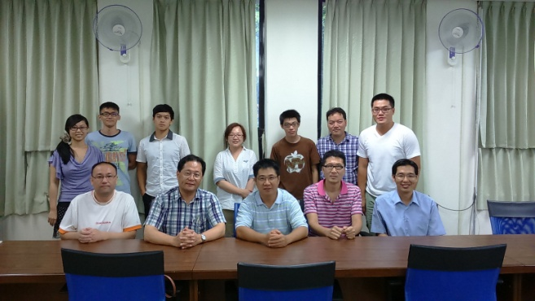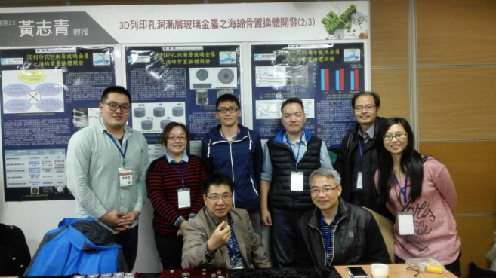

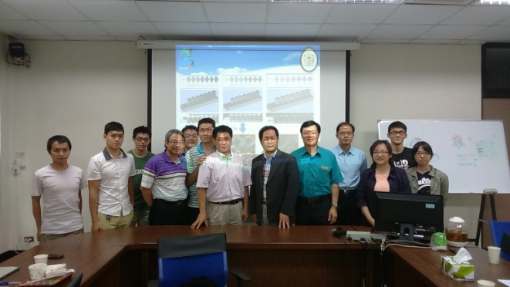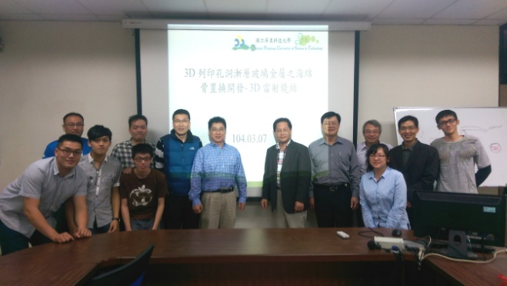
團隊照片

